1. Create Email verification page
2. Login page is very blank, need some color and design in it. (read my note on end of this page first)

No account? Sign up now. Should be at the bottom

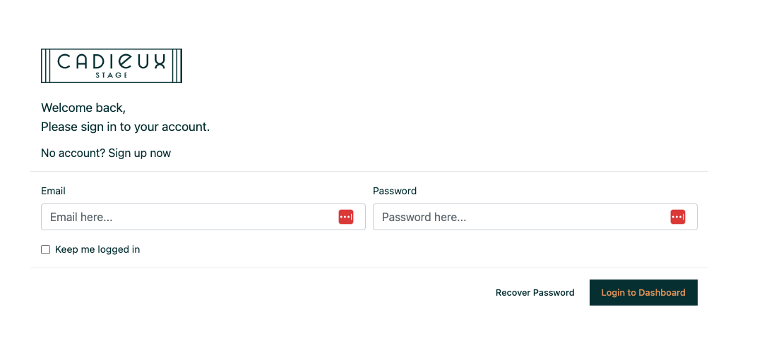

1. Register page needs to be improved

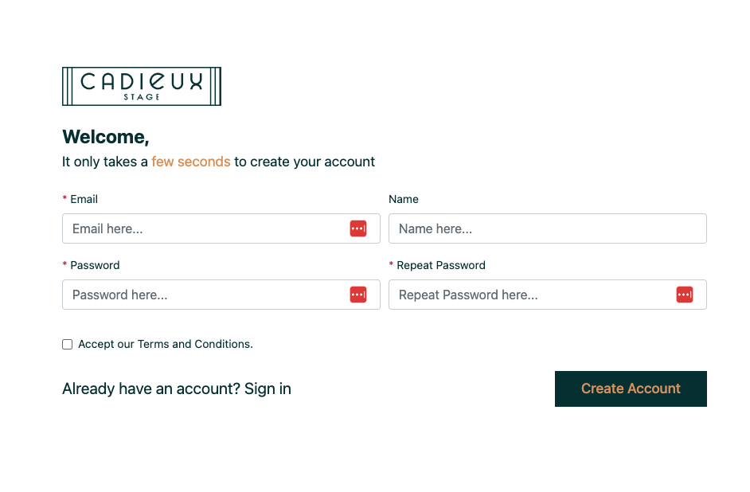

1. Same for forgot password. Needs a better design.

NOTE: For login, signup, forgot password, email verification page, you can also follow such a layout where half the screen on left side shows an image of their studio (take that from XD) and on the right half is the form on all these pages. They have a studio, so the design should be according to showbiz industry, also take inspiration from their home page UI.

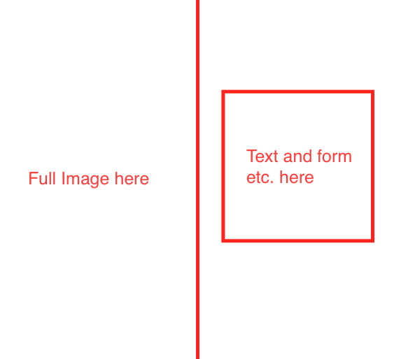

1. Gold on black is not very visible

 Try something else

1. Space details page needs to be updated

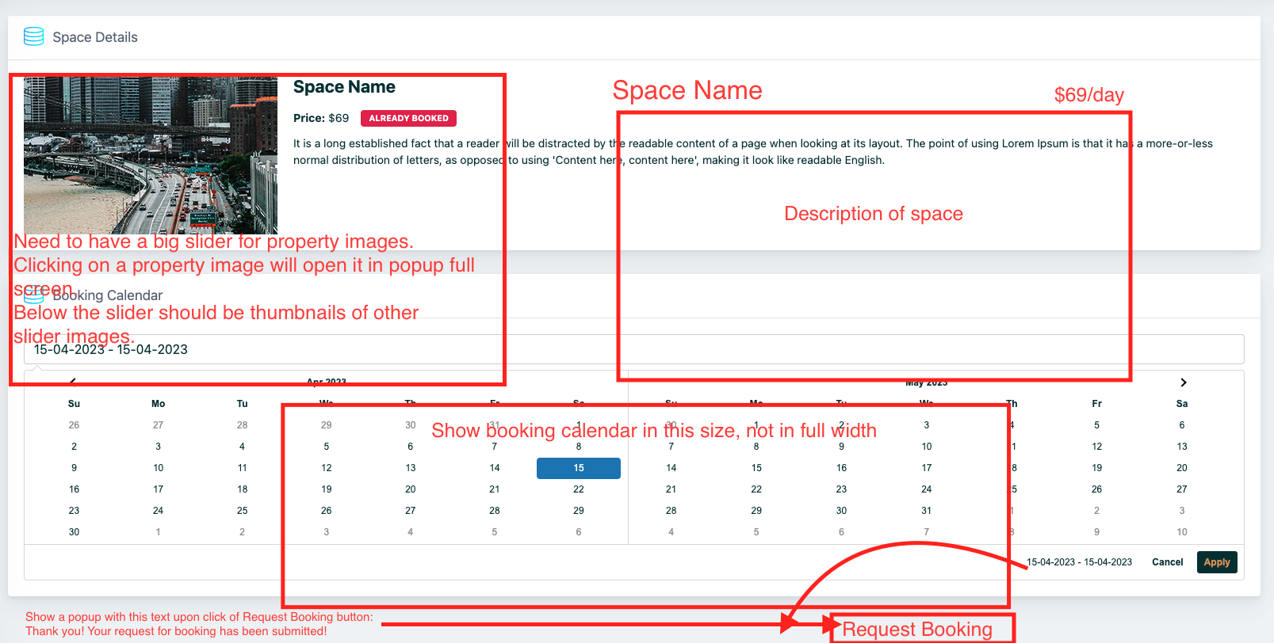

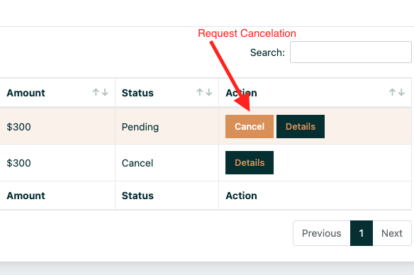

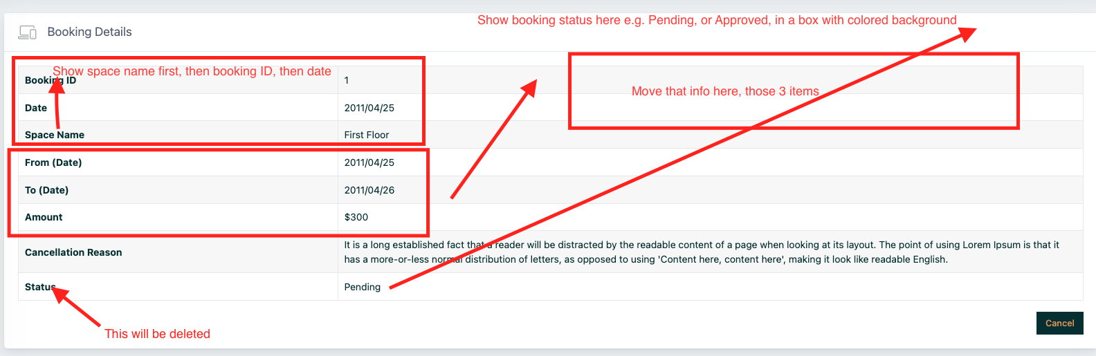

1. Show Amount Due also

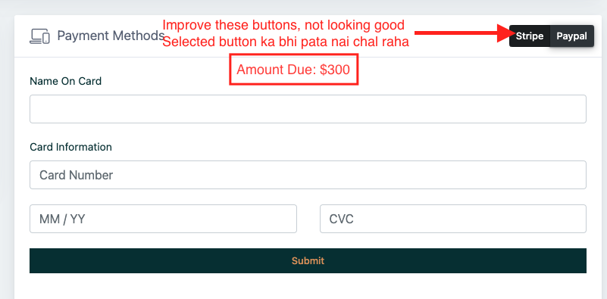

1. Color scheme is not very user friendly, and use proper icons.

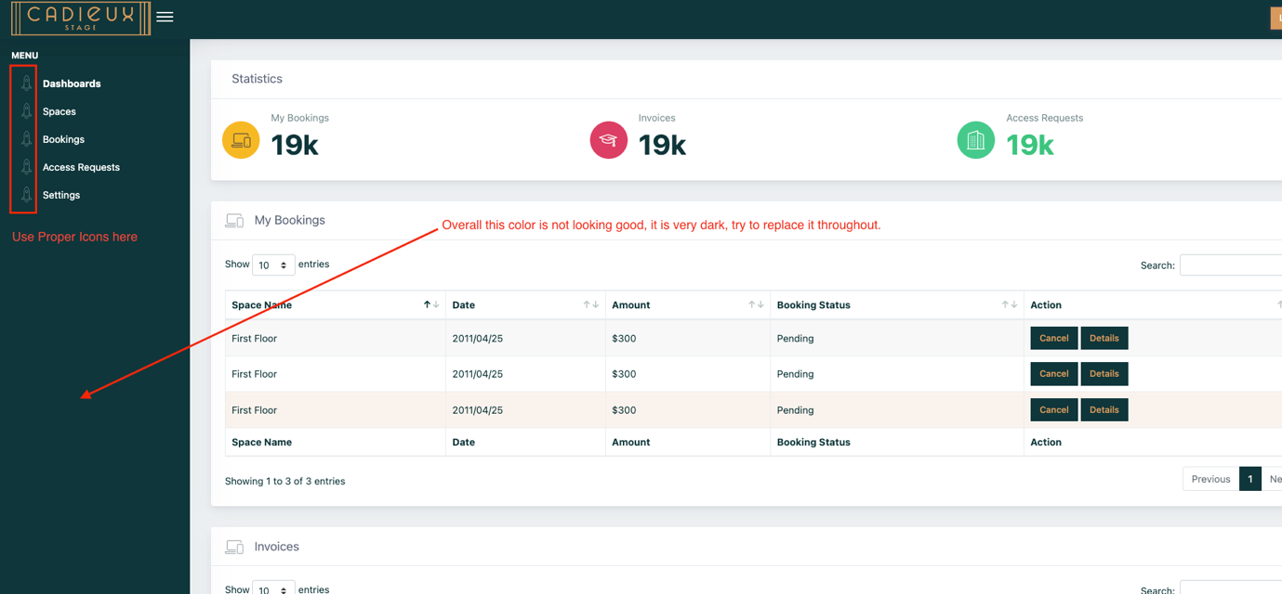

1. Check responsiveness.